eCMS MANUAL

DECLARATION(RegimeEXPORT)

Department of Revenue and Customs
Ministry of Finance
Table of Contents
1. Login as Front-end user 2
2. Create Export Declaration 2
3. Track Application 5
4. Search amendment request 6
5. Create Amendment request! 6
6. Search Cancellation 6
7. Create Cancellation 6

Login as Front-end user

- The user needs to log into eCMS using the url: www.ecms.gov.bt

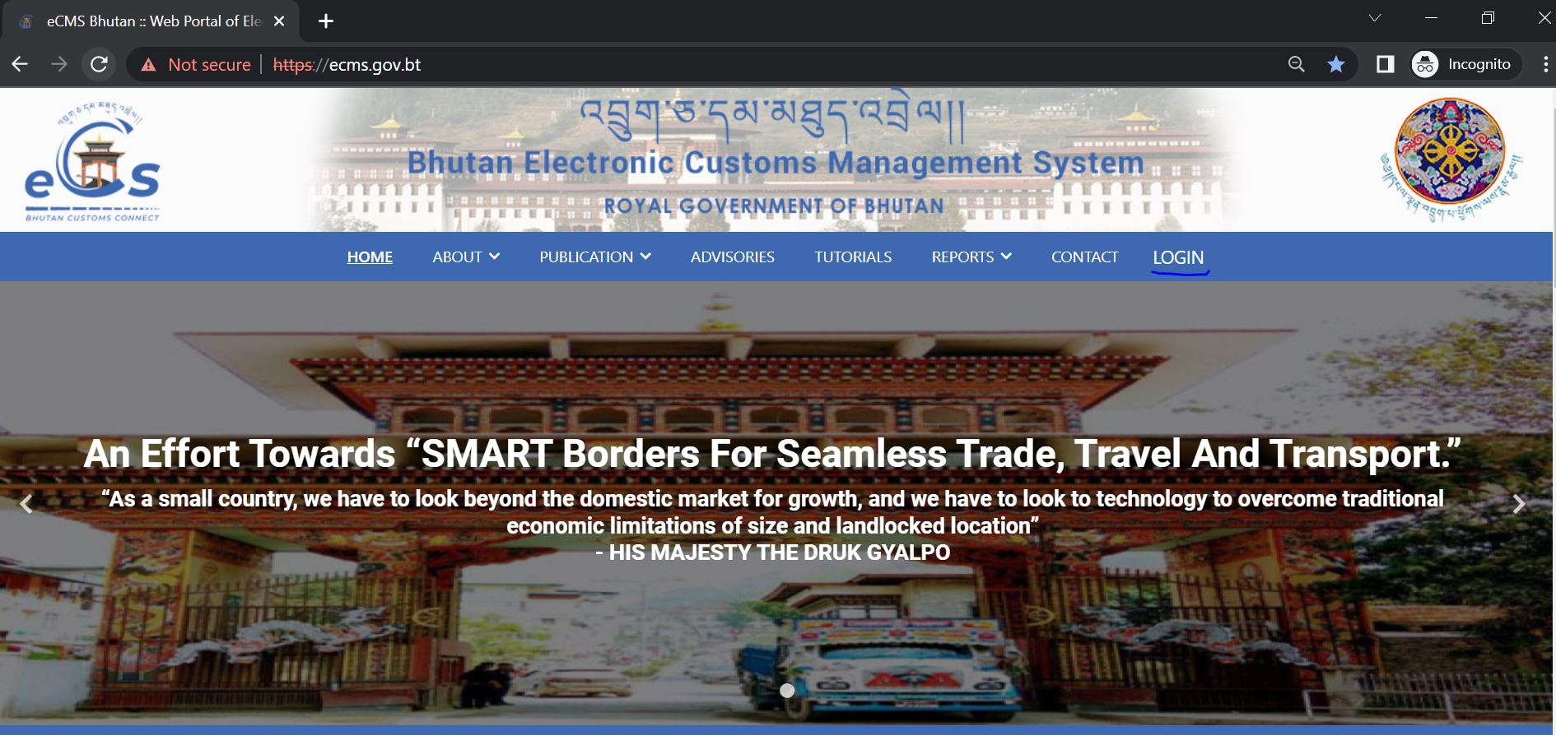

- Click on login menu and provide the required credentials to log in to the system:

Create Export Declaration

- Select Declaration FE for the list of menus provided in the dashboard:

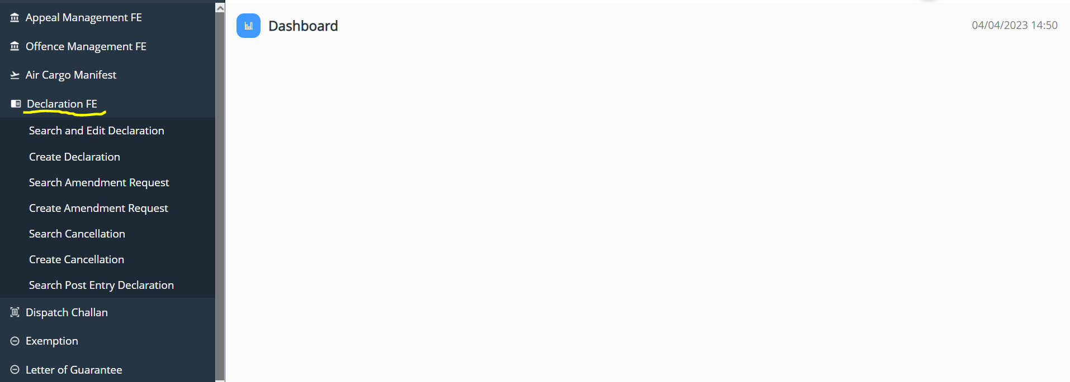

- Under the Declaration FE menu, Select Create Declaration:

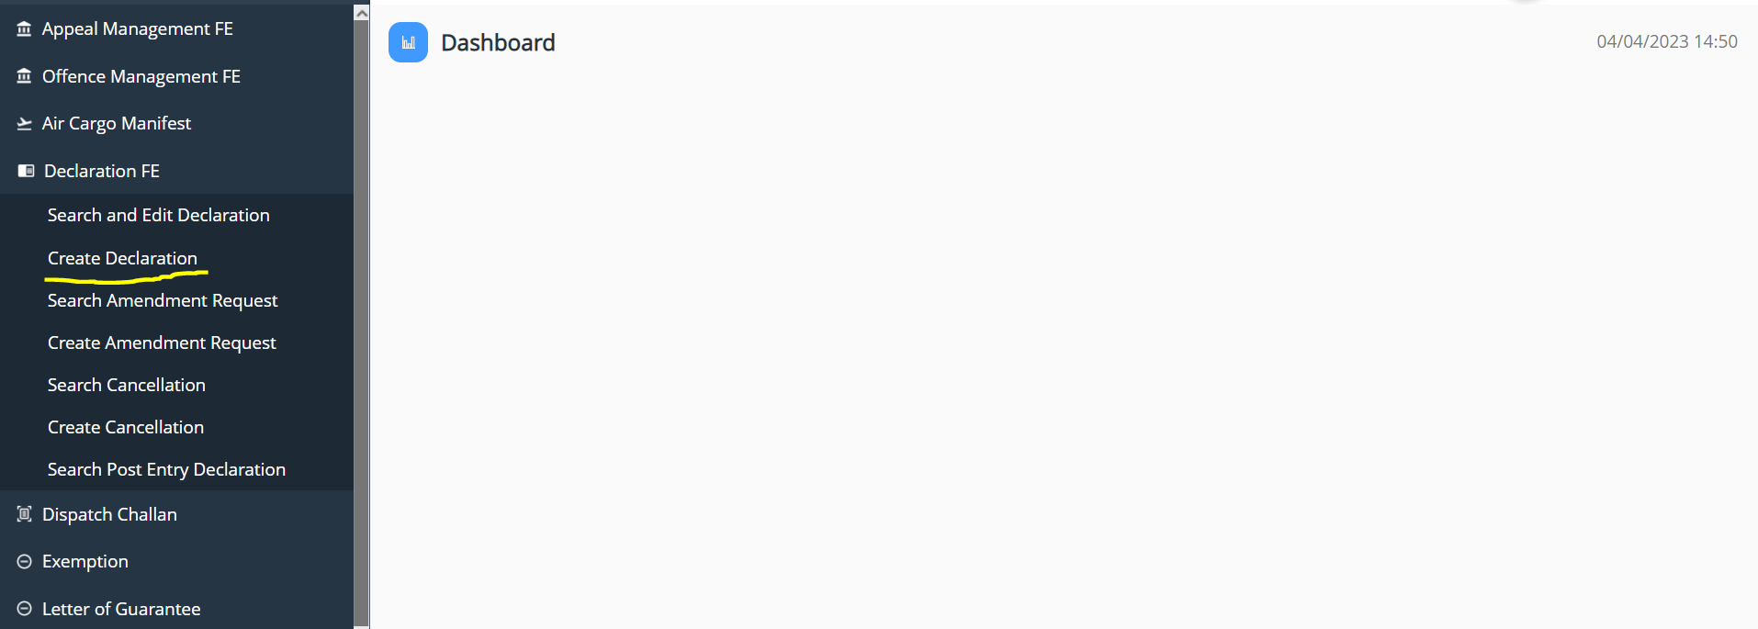

- Key in the following details:

- General information

- Select the Regime as Export >> Select Declaration type as per the requirement and get the details filled and save the data that has been completed.
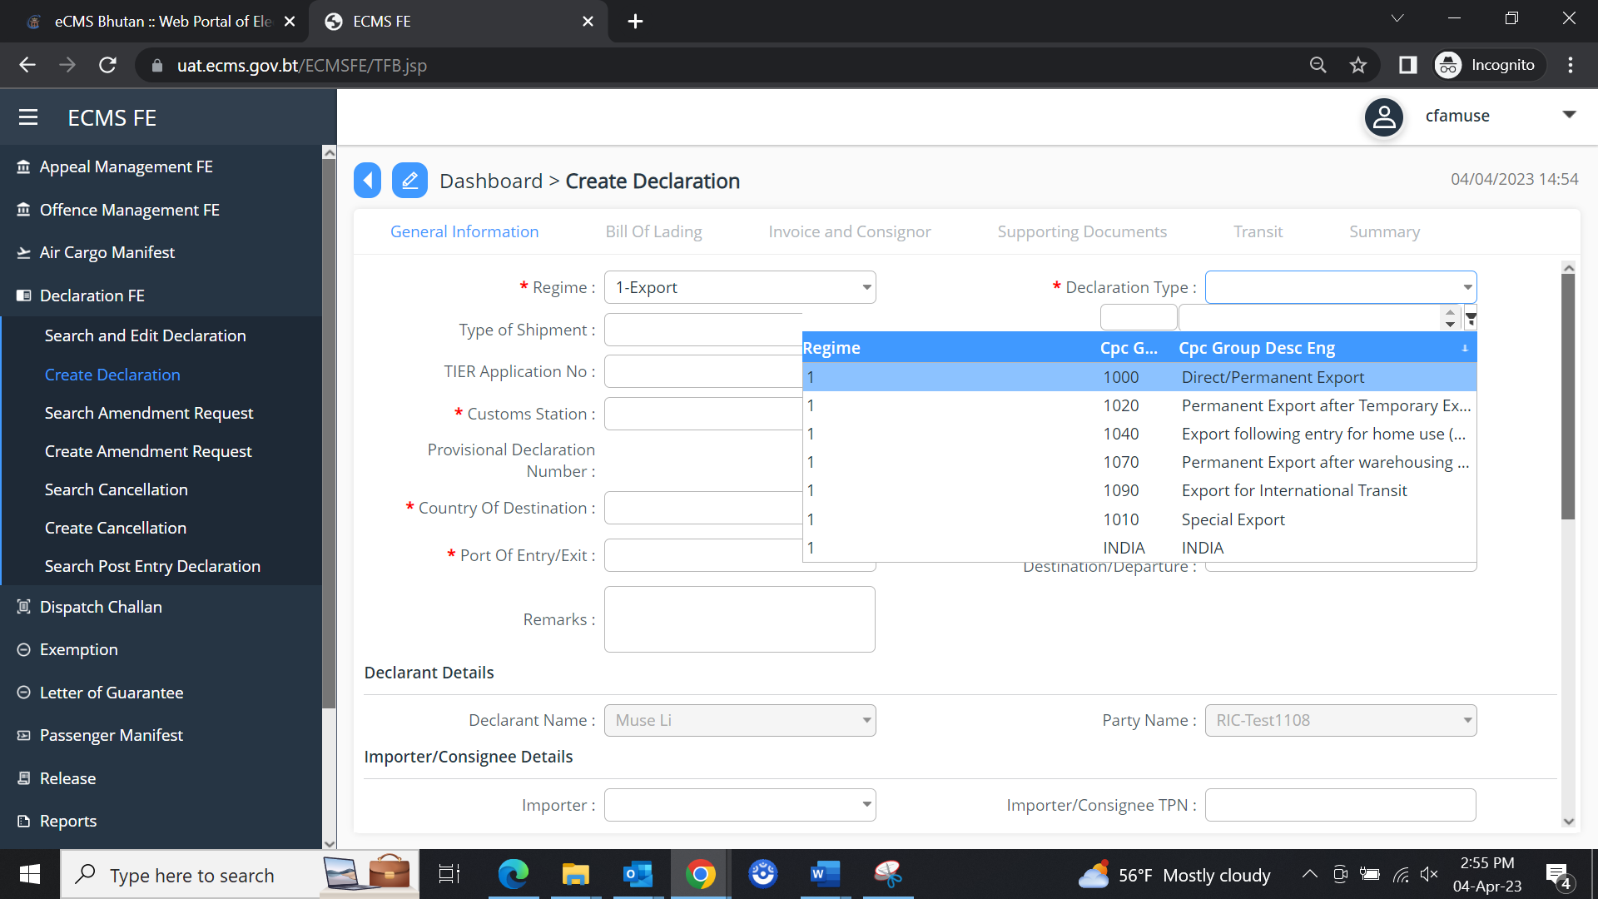

- Bill of Lading

- The user needs to add in the Bill of landing where in we have to have Road Manifest details:
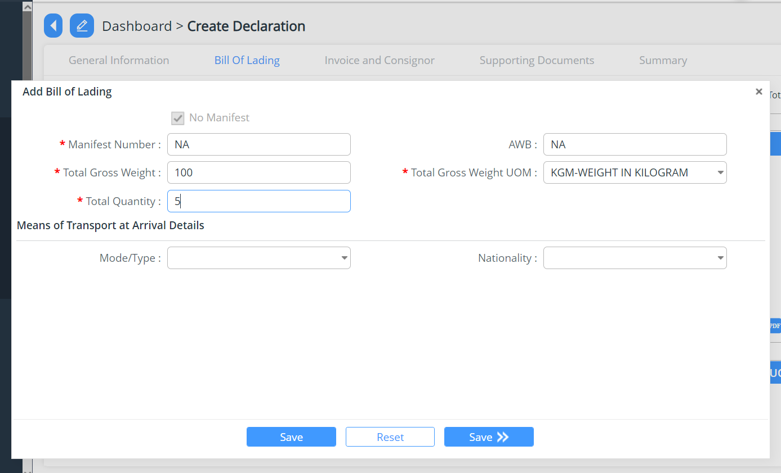

- At times we have a container associated in the consignment, the details of the container will then have t be added under the Bill of Lading , into the Container details
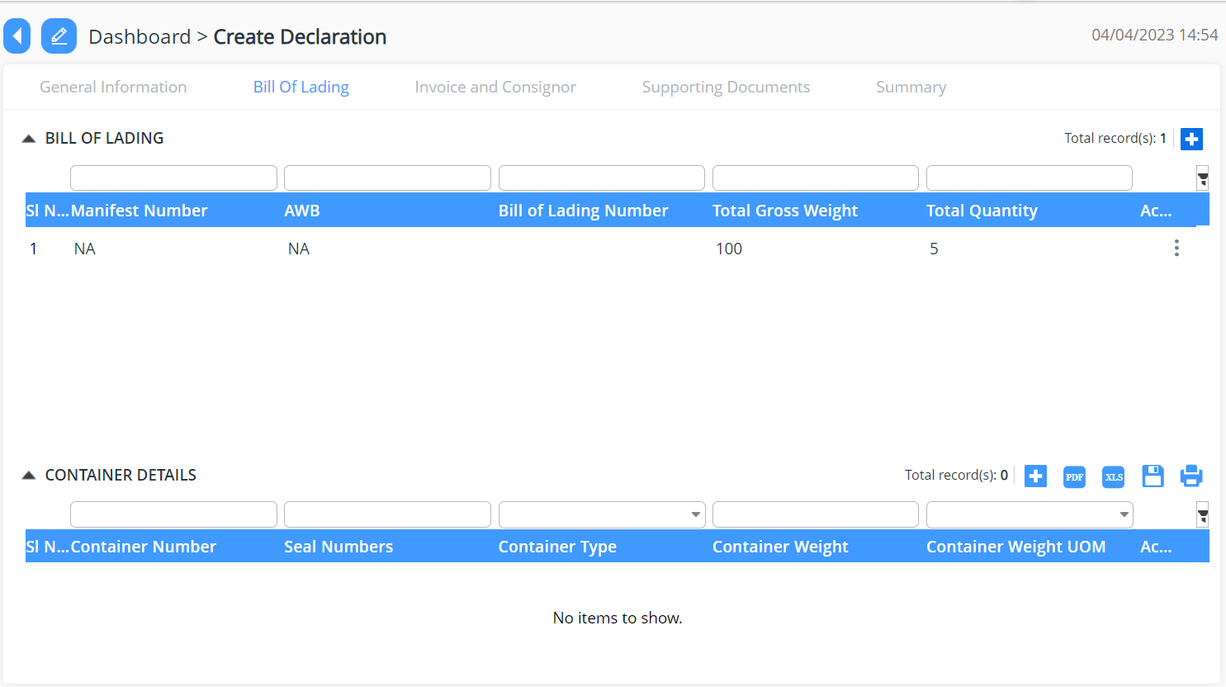

- Invoice and Consignor

- Add New invoice and consignor details >> add in the invoice details and commodities details >>Save
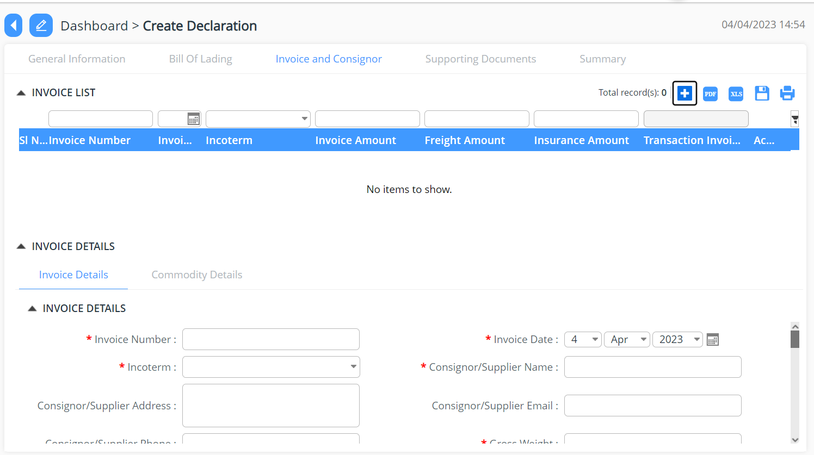

- Supporting Documents

- The declarant shall attach mandatory supporting documents (invoice) for approval:

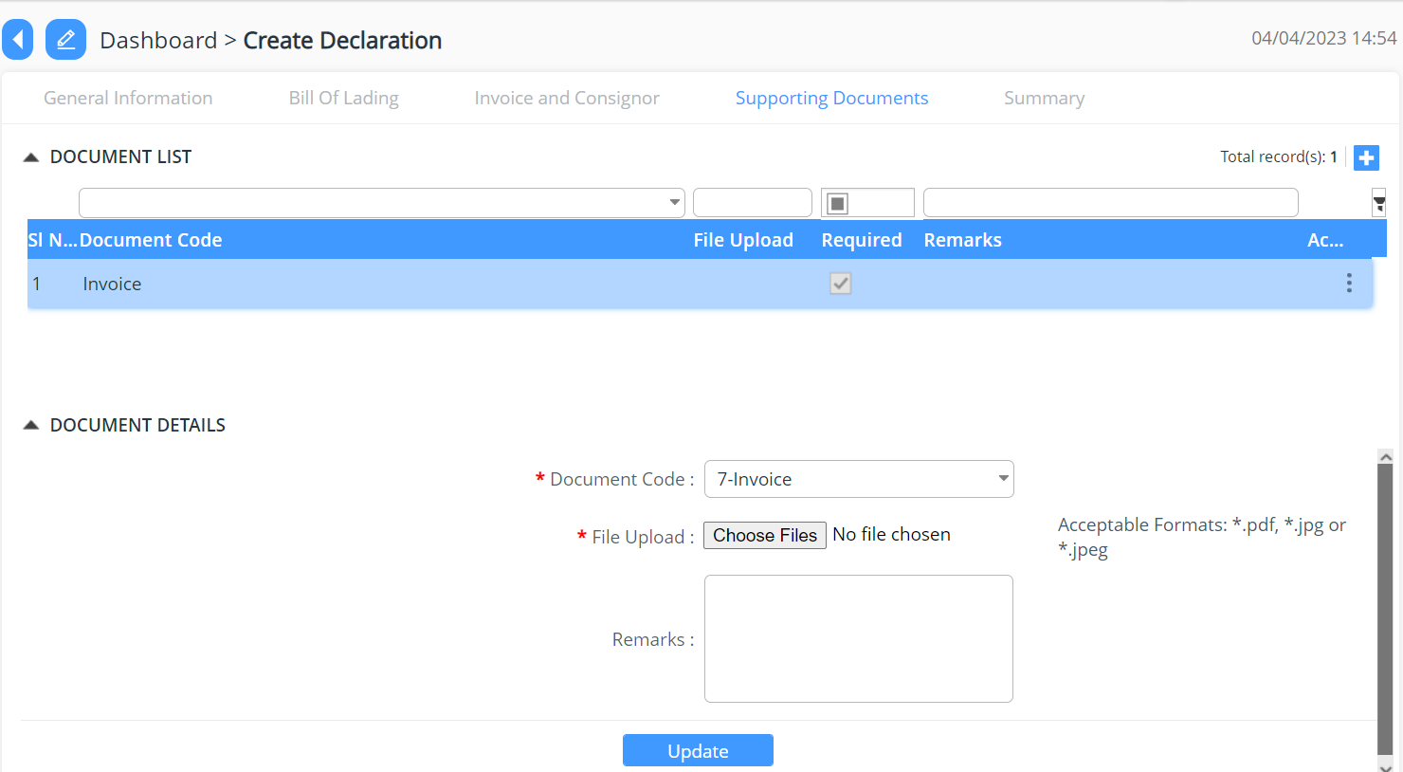

- Summary

- The declarant can review his/her declaration summary and submit the same for approval, here we have the check box to accept the terms and condition.
- Here the user can validate the declaration before submission.
- The user can submit the declaration which will allow the user to generate the reference declaration number.
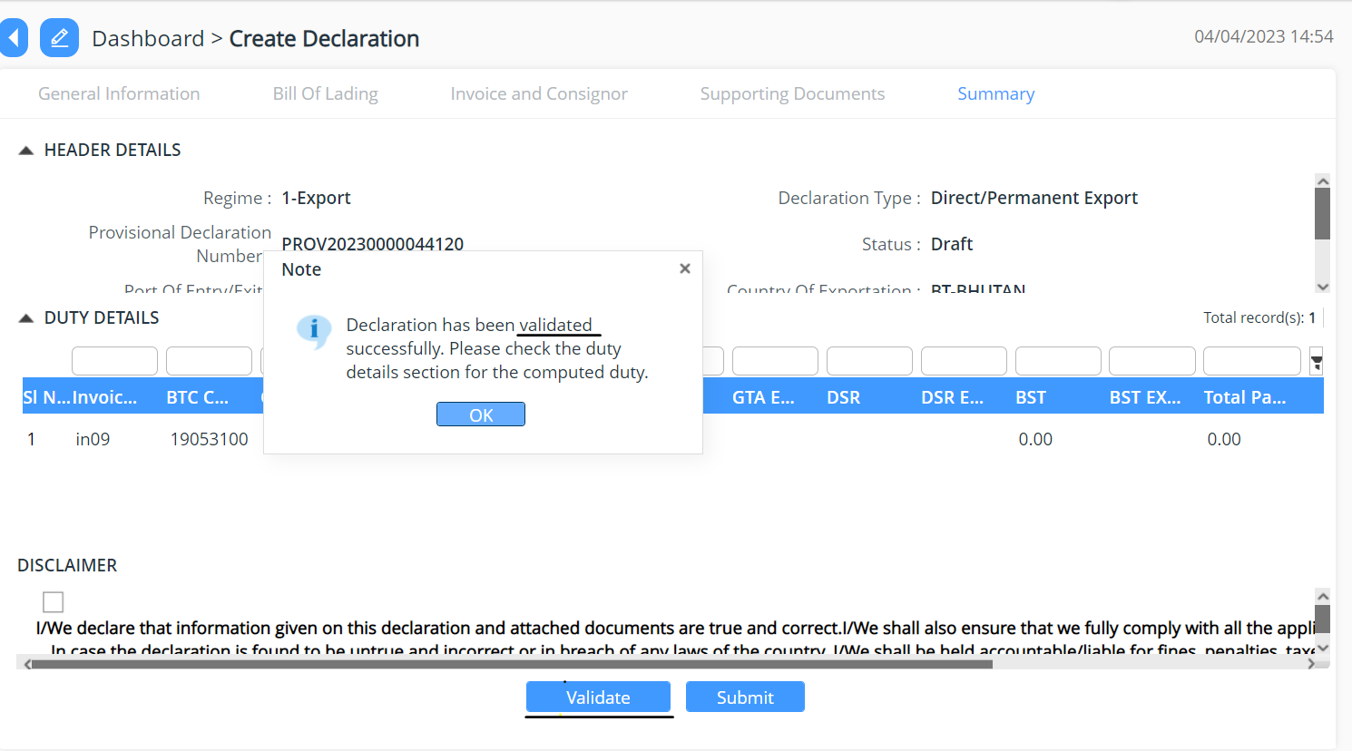

Track Application

- An application Number will be Generated:

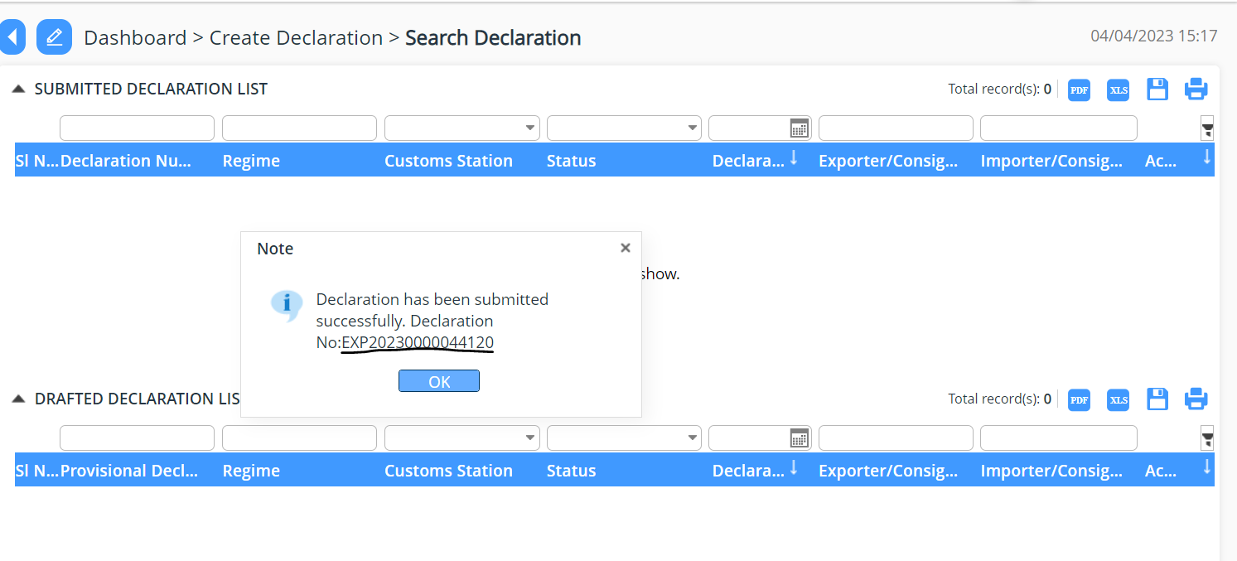

- The users will be able to track their application from Search and Edit Declaration:
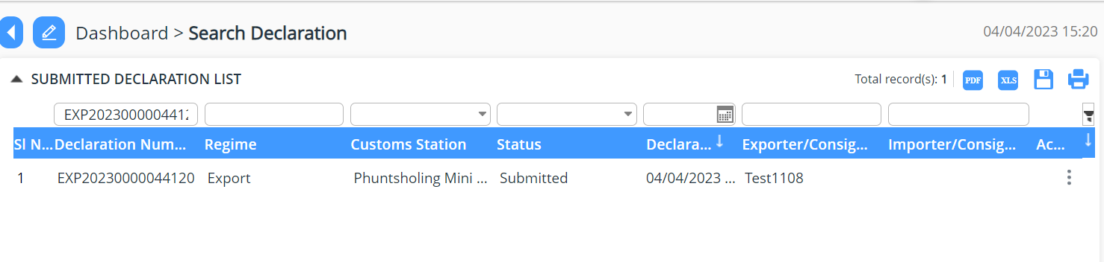

Search amendment request
- User are provided view of the list of declaration that has been for amendment

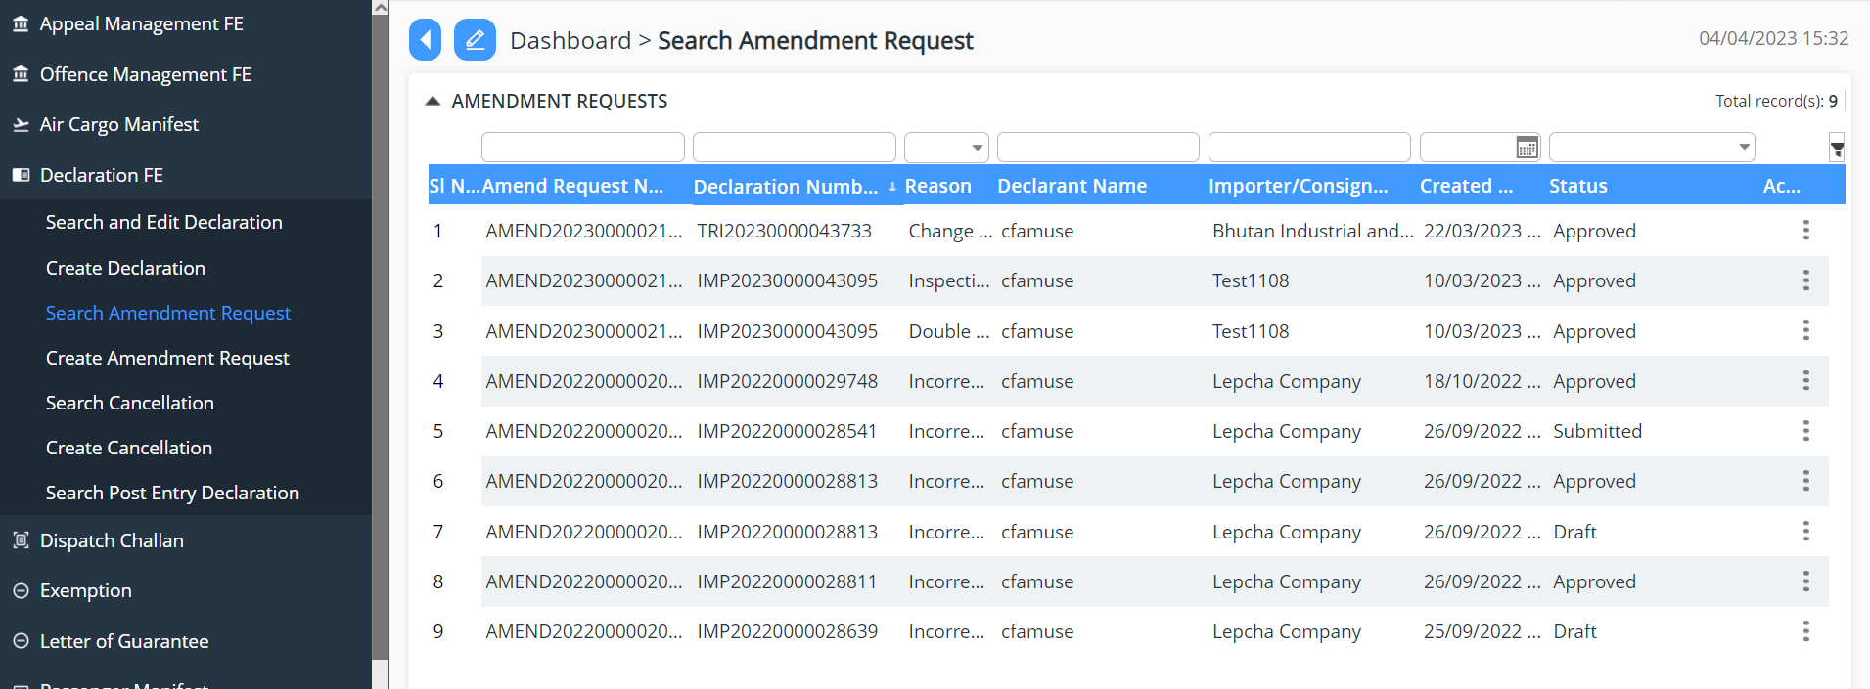

Create Amendment request!
- User can request for amendment of declaration that has been submitted.

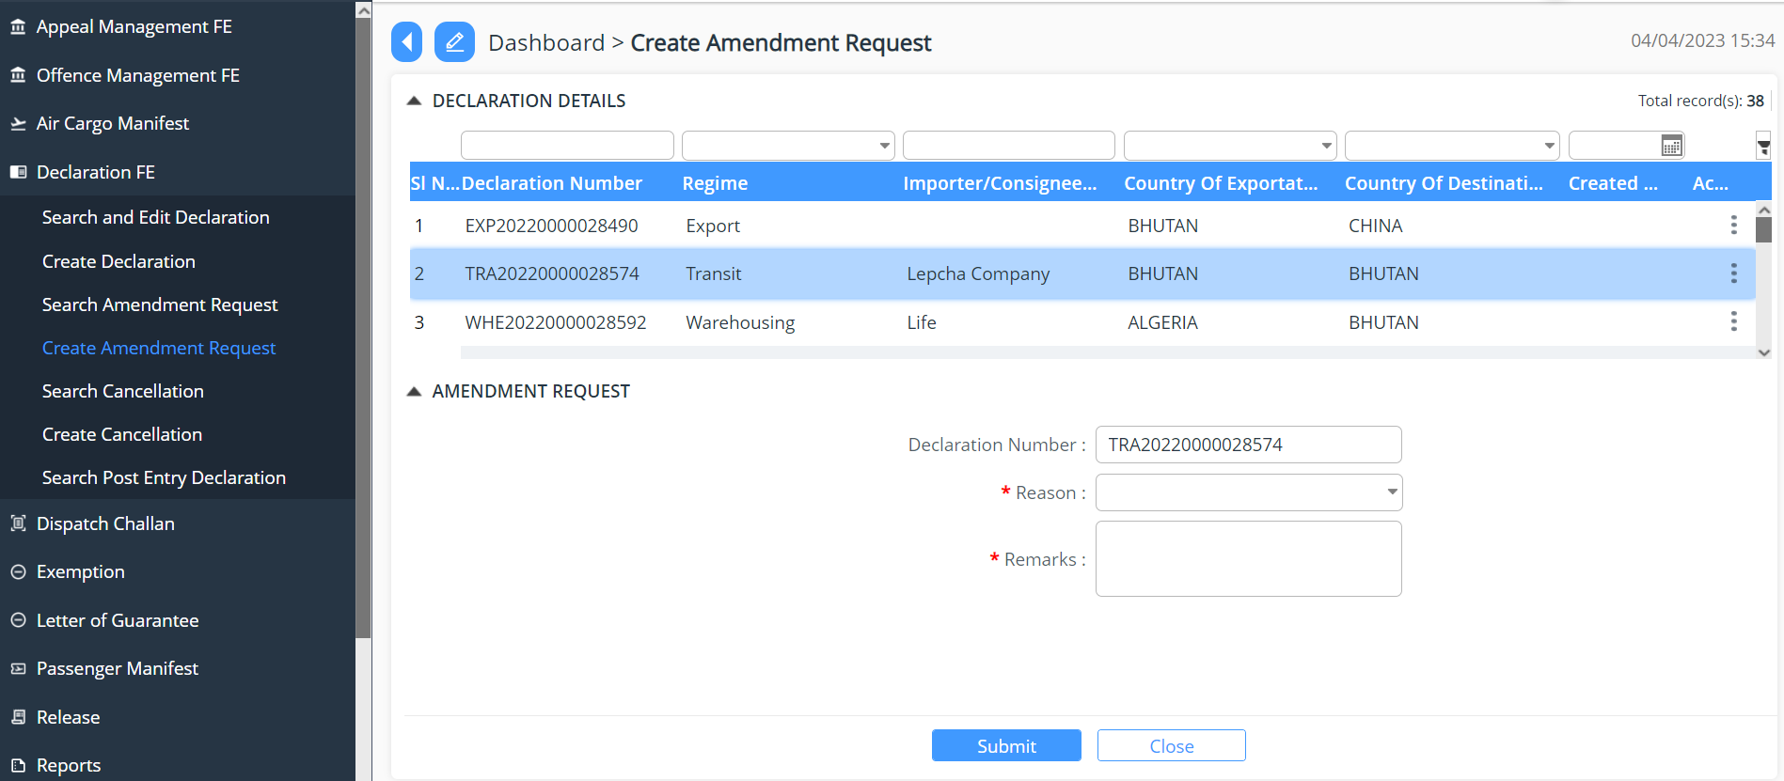

Search Cancellation
- User are provided view of the list of declaration that has been requested for cancellation.

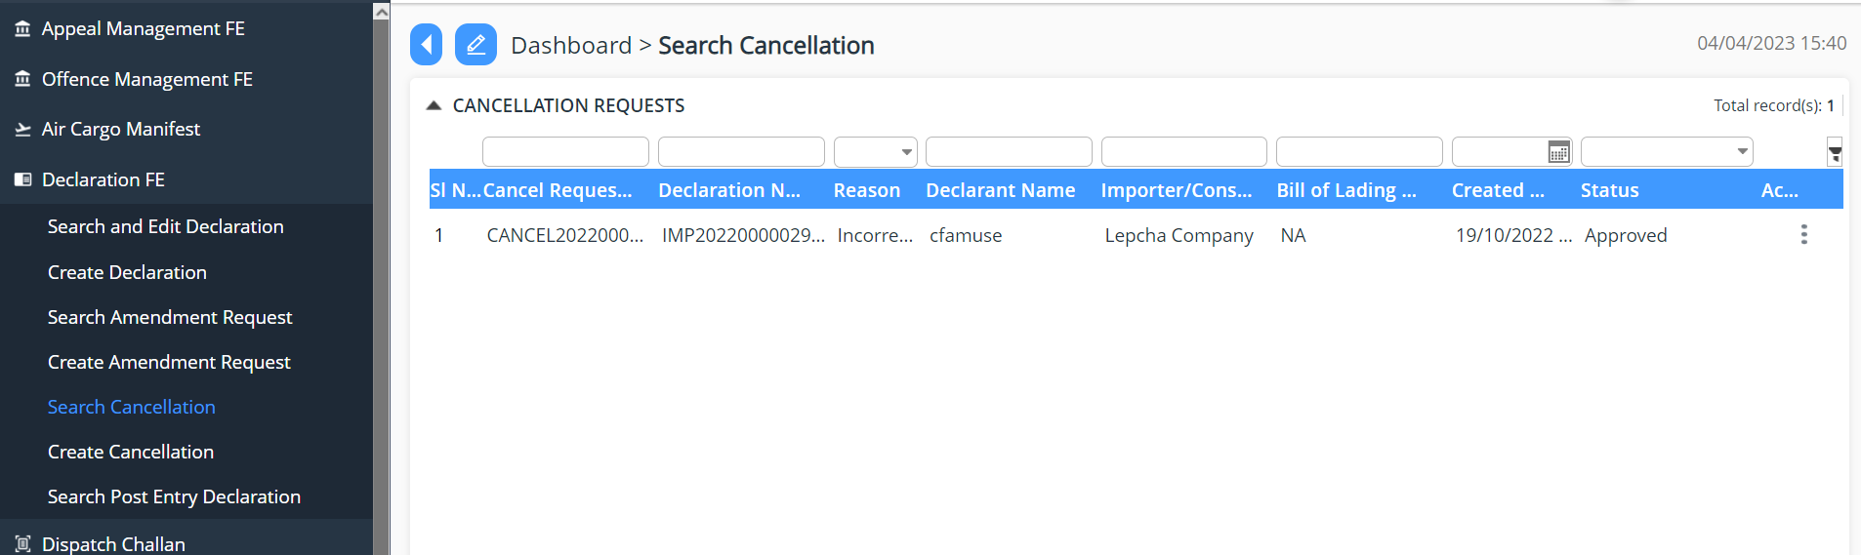

Create Cancellation
- User can create cancellation request for the declaration applied for are provided view of the list of declaration that has been requested for cancellation

